


Project Name

Project Plan

Version

Revision History

Date | Version | Description | Author
2002-00-00 | 0.01 | Initial Draft

Table of Contents
1.Introduction 4
1.1Purpose of this document 4
1.2Intended Audience 4
1.3Scope 4
1.4Definitions and acronyms 4
1.4.1Definitions 4
1.4.2Acronyms and abbreviations 4
1.5References 4
2.Background and Objectives 4
3.Organization 5
3.1Project group 5
3.2Customer 5
3.3Supervisor 5
3.4Others 5
4.Development process 5
5.Deliverables 5
5.1.1Remarks 6
6.Inputs 6
6.1.1Remarks 6
7.Project risks 7
8.Communication 7
9.Configuration management 7
10.Project plan 7
10.1Time schedule 7
10.1.1Remarks 8
10.2Activity plan 8
10.2.1Remarks 9

Introduction

Purpose of this document
Define the purpose of this document. At what phase of the project work is this document defined, and revised. What other artifacts / documents are based on this document?

Intended Audience
Define who and why should use this document, in what phases of the project work?

Scope
Define what will be covered by this document? What artifacts / project properties (in general) shall be covered by this document and what shall not (is not part of the developed project).

Definitions and acronyms

Definitions

Keyword | Definitions

Acronyms and abbreviations

Acronym or  abbreviation | Definitions

References

Background and Objectives
Describe (in general) goals of the project. Describe (in general) project requirements, milestones, deliverables, testing, product delivery.

Organization
Describe project composition (team members, distribution of team members, roles defined in the project team. State tools used to support the development process (emphasize should be on tools supporting project management, collaboration, not development tools such as Eclipse, C compiler …)

Project group
Explicitly list all project team members and their responsibilities. Project leader and team leader should be at top of of the table (PL in bold, TL in bold italic font).

Name | Initials | Responsibility (roles)

Customer
List product customer, company.

Supervisor
List project supervisors.

Others
List other people (if any) involved in the project, their roles and significance for the project.

Development process
Describe development process used to build the product, project phases. Describe specific roles in a development process used (for example scrum master, product owner if SCRUM is used etc.). No not forget to address quality assurance procedures to be used throughout the product development process. Use subsections to logically divide content of this section.

General Overview
We will use elements from the waterfall and incremental development process in order to fulfill both the requirements of the customer and the course. The documentation will be delivered in a waterfall kind of way, sequentially. However, the requirements and design phase will be distributed throughout the whole project, with multiple increments of the system being delivered after a certain amount of time.

First Phase of Project
In the first phase of our project we will focus to prepare the Implementation and build a good basis for later work. For this we have the two main aspects, the analysis of requirements and the design of the system. In this phase we will organize the project sequential as known from the waterfall model.

Three Packets of Product-Development
In the waterfall model the phase of system design is normally followed by the Design of the Program. At this point we want to leave the normal waterfall model and choose a incremental model. Instead of only on phase of program design, implementation and testing, we bundle this three phases to a packet and repeat this packet three time. After the first bundle of program design, implementation and testing, we will be able to deliver the customer the first alpha prototype.

Quality assurance
Because of the mix between the classical Waterfall model and an incremental development process. we are able to provide a high quality during this project. During the first stage we will figure out what we have to do and in witch way we will solve the problem. In this phase the contact with the customer is very important.
After the next phase we provide the alpha prototype. So the customer has the possibility to see the direction of the development.. The same is after the beta prototype.
In the last stage, we planed the last two weeks for testing and bug fixing. So we could be able to deliver a product with best quality.

Deliverables

List all deliverables (documents, software components, libraries, programs etc.) produced by this project. To column should contain the person/group the deliverable was handed to (customer, internal deliverable of, for example, library), Output should contain the name / short description of the deliverable (document, library, GUI component, interface etc.,), Planned week no, Promised week no and their difference, ending with possible remarks that are defined in more details in the description table below. Note that “Milestones” and “Work products and deliverables” tables are not the same! There are many more items in this table, especially regarding internal work products, used by other team members/subgroups, which are never delivered to project customer(s)!

To | Output | Planned week | Promised week | Late +/- | Delivered week | Rem

Remarks

Remark Id | Description

Inputs
Fill the table with inputs (artifacts required to complete your project, but out of your control – for example library developed by another project, example data provided by the project customer etc.). During the project track whether the inputs have been delivered on time. Include inputs in risk table and try to develop preventive actions and strategies in case inputs are late or never delivered.
From | Required item | Planned week | Promised week | Late +/- | Delivered week | Rem

Comment: Required week = week when it is required by the project; Promised week indicates when the From expects to deliver; Late + indicates a discrepancy between Required week and Promised week; Received week is week when it was actually received; Rem is a remark index number.

Remarks

Remark Id | Description

Project risks
Identify as many project risks as possible, state their possibility of happening in the project (low, medium, high), and write down what will be the strategy of the project team to avoid the risk.
Possibility | Risk | Preventive action

Communication
Describe communication strategy in the project team – how to ensure seamless information flow among team members, regular meetings, minutes of meeting documents (who will write them, where will they be published), synchronous and async communication tools, how to identify and contact responsible team members, other tools for awareness, ticketing, project management, … use subsections if necessary (7.1. Meetinfgs, 7.2. Maling list, …). Use subsections to logically divide content of this section.

Configuration management
Describe configuration mgmt. plan, coordination, tools used, backup, preventive actions and corrective actions when the system is not used properly by some team members.. Use subsections to logically divide content of this section.

Project plan

Time schedule

Id | Milestone description | Responsible dept./initials | Finished week |  |  |  | Metr. | Rem.
Id | Milestone description | Responsible dept./initials | Plan | Forecast |  | Actual | Metr. | Rem.
 |  |  |  | Week | +/- | Actual | Metr. | Rem.

Comment: Finished week: Plan = original plan; Actual = week when it was actually available; Forecast Week indicates the estimated finished week; Forecast +/- indicates changes in the estimation compared to the previous project report; Metr is the difference between Plan and Actual, that is if Plan is w604 and Actual is w606, then Metr will be -2. To be filled in when the milestone is reported as completed; Rem is a remark index number.

Remarks

Remark Id | Description

Activity plan

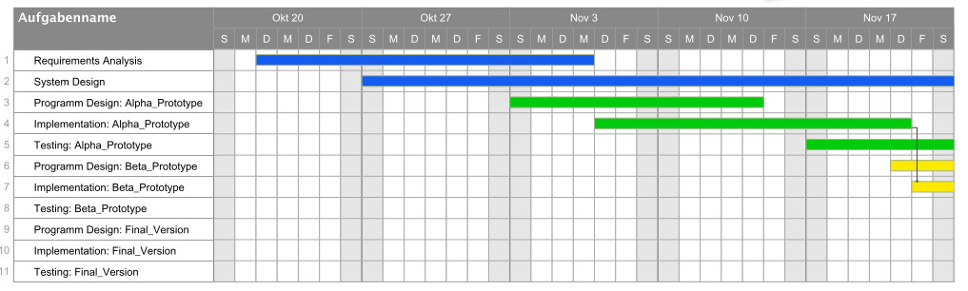
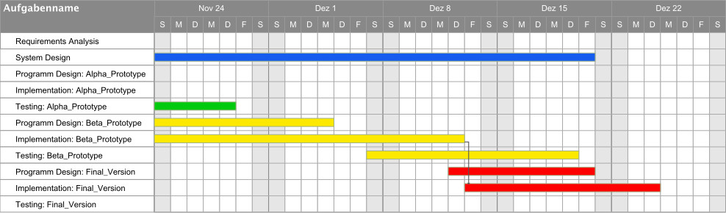
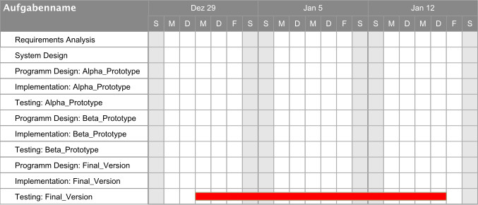
Insert a Gantt chart that depicts all activities defined in the table below, their dependencies etc. Gantt chart can be copied from PM software used for project management (MS Project, Redmine etc,). In the accompanying text, comment on the plan and identify critical path(s), measures to lower the risk for being late.
Also, clearly define groups of activities – for example runs in SCRUM, iterations in iterative development etc.

The table should contain activities in the project (will evolve over time). ID – ID of the activity, Predecessor – activity ID(s) this activity relies on to be finished, Activity – short name of activity, Days – expected duration of activity in days, Mdays – expected duration in man-days, Rem – remark id

ID | Predecessor | Activity | Days | Mdays | Rem.
1 |  | Requirements Analysis
2 |  | System Design
3 |  | Program Design: Alpha Prototyp
4 |  | Implementation: Alpha Prototyp
5 |  | Testing: Alpha Prototyp
6 |  | Program Design: Beta Prototyp
7 |  | Implementation: Beta Prototyp
8 |  | Testing: Beta Prototyp
9 |  | Program Design: Final Version
10 |  | Implementation: Final Version
11 |  | Testing: Final Version

Total planned calendar days for the project to be finished and total planned man-days required to finish the project
Planned effort (days) | Planned effort (man-days)

Remarks

Remark Id | Description

